

Net-Inspect CAR Training
Quick Response Guide
Responding to a Customer CAR in Net-Inspect

Version 5 – Last Updated 2/21/2023

INTRODUCTION

Welcome! This training guide will explain how to quickly get started to respond to a CAR within Net-Inspect’s software.

General Content

INTRODUCTION 2
1.0 How to start using Net-Inspect, general navigation 4
1.1 Accessing Net-Inspect 4
1.2 Requesting a Net-Inspect account 4
1.3 Logging on to Net-Inspect 4
1.4 Ensure you have CAR User and Reviewer Access 4
2.0 Notification of Corrective Action Request 5
3.0 Locating CARs issued to your company 6
5.0 START the CAR 7
6.0 Email Notifications 8

1.0 Accessing Net-Inspect, general navigation

1.1 Accessing Net-Inspect

Using the browser on your PC, you can access Net-Inspect at this address:
www.net-inspect.com > SIGN IN.

1.2 Requesting a Net-Inspect account
If you don’t already have a Net-Inspect account, go to Net-Inspect.com > REQUEST AN ACCOUNT > Enter Amphenol IPC as your customer on the request an account form. Net-Inspect helpdesk will setup your account within 1 business day. If your company already has a Net-Inspect account, please get in touch with your local administrator.

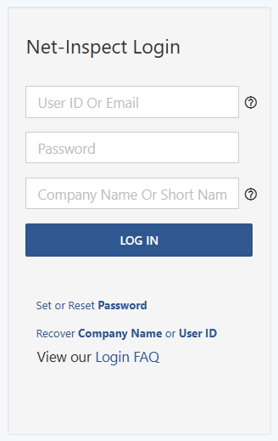

1.3 Logging on to Net-Inspect

Enter your credentials.

Use the credential recovery links
if you need help with logging in. Note: Be sure your company name matches what was issued when your account was created.

1.4 Ensure you have CAR User and Reviewer Access

Your user account needs the CAR User and Reviewer User Roles. This is done by your account administrator. Look up your admin with these directions.
These roles can be added in Settings (gear icon) > User Management > select a user > Add CAR User and CAR Reviewer to the user. The user will need to log out and log back in again to have access.
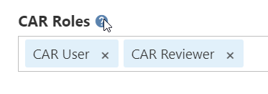
You will also need program access with these directions.

2.0 Notification of Corrective Action Request

If your company is already setup with a CAR User role, the customer has the ability to select a supplier representative, whom will receive an email like the below when the CAR is issued:

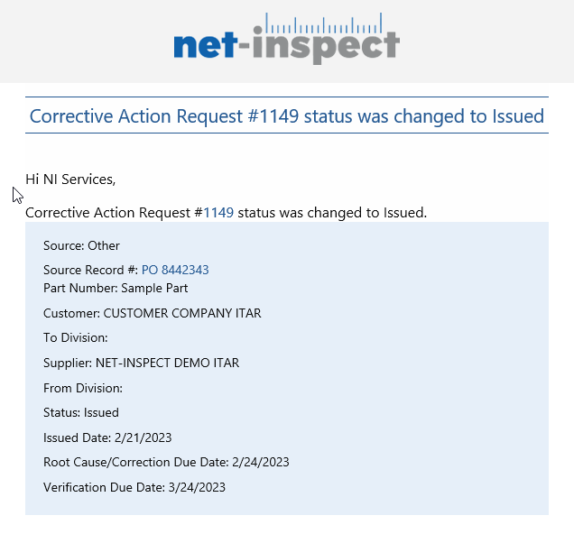

3.0 Locating CARs issued to your company
Navigate to CAR > View Customer CARs. You will find the CARs in “Issued” status.
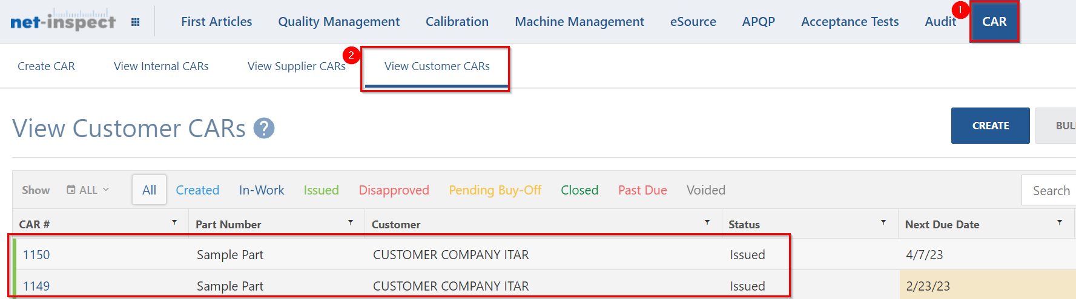
To view more status definitions, please see this help article.
Click to open one of the issued CARs.
4.0 Navigating to open the CAR
The top portion of the CAR will contain General Information. Enter your supplier representative name and email if it is not present.
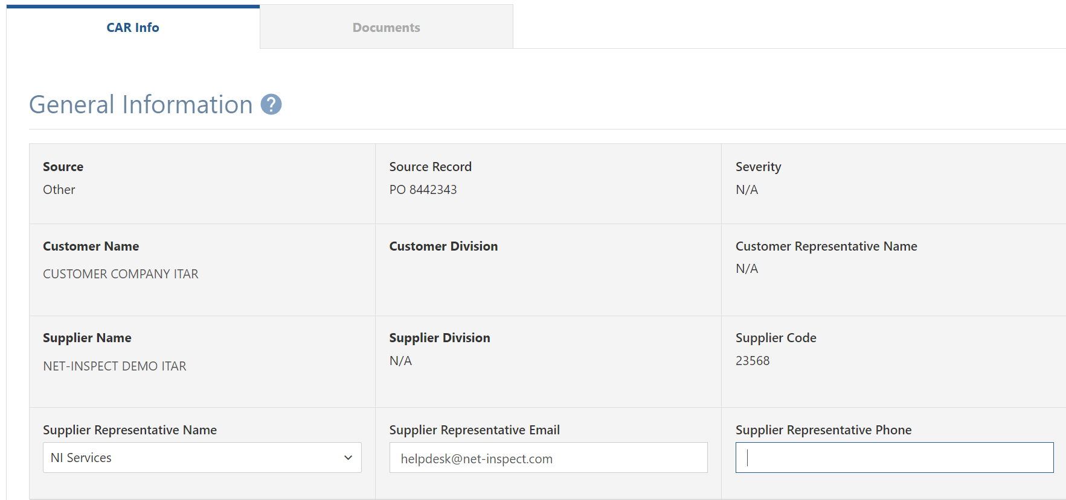
The second section of the CAR contains the Description of the Nonconformity
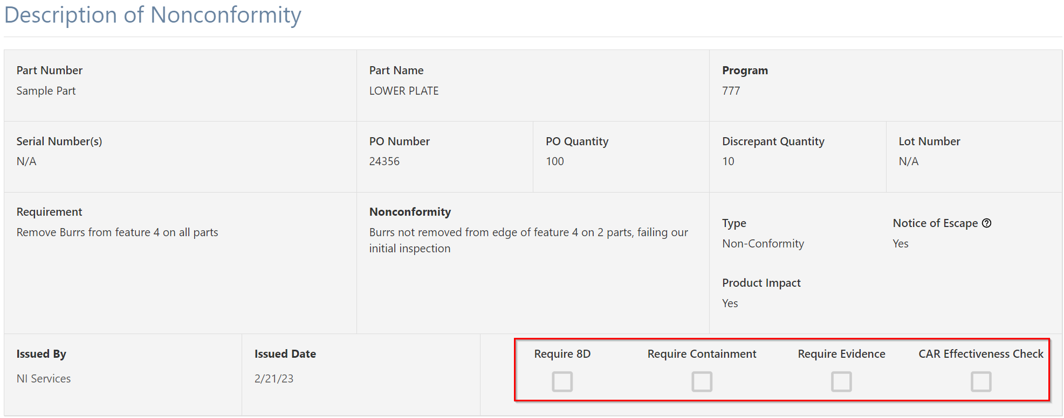
Depending on the checkboxes checked, the rest of the CAR will be dynamic.
With no checkboxes, you will have a Root Cause / Corrective Action Plan and Implementation Verification section.
To view information on each of the sections, please see this help article. Each section adds additional or different CAR response requirements.

5.0 START the CAR
In the upper right corner of the CAR, click the START button to get started.

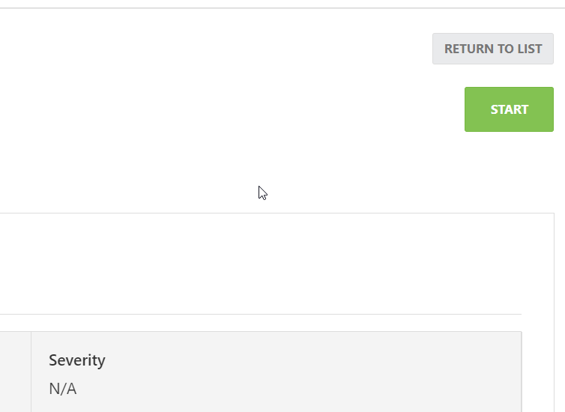

In a standard CAR with no options checked in the Description of Nonconformity section, the Root Cause / Corrective Action Plan and Implementation Verification is open for editing. As you enter text in each of these Net-Inspect will save your entries as soon as your cursor is moved to another text box, you can also click SAVE if desired. When you are done with a section, use the SUBMIT button to enter your Net-Inspect credentials to sign off on that section.
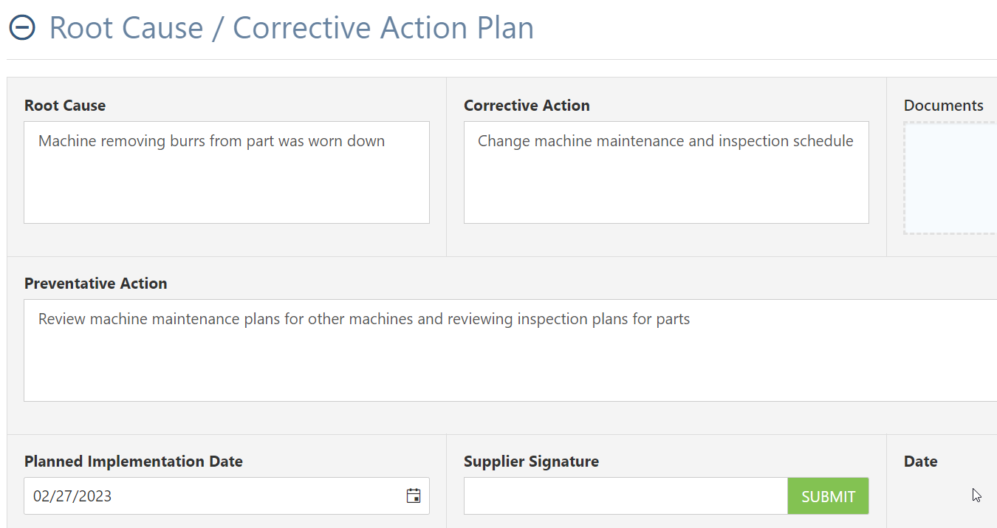

Continue to complete each section prior to each sections due date. Signing a section will move the CAR into a “Pending Buy-off” status notifying your customer to approve that section. It is not necessary to await approval if you are continuing to work on further sections of the CAR.

Note: If “Require Evidence” is checked, then each section that has a document upload option must have evidence documentation attached.

8D CAR Important Notes:

D1: You must add at least two members on the team
D3: You must add a completed date prior to signing, use the pencil edit icon to enter the completed date.
D6: You must enter a completed date on D5 items in order to sign.

6.0 Email Notifications

Notification Details
Each user associated with a CAR will get an email notification once a status changes or a section is signed almost immediately.

Additionally, all users will get an email once a day with updates regarding all open CARs and detailing CAR status and due dates.

Each CAR is linked within the email for quick access. Internal Net-Inspect sources are also linked for ease of access:

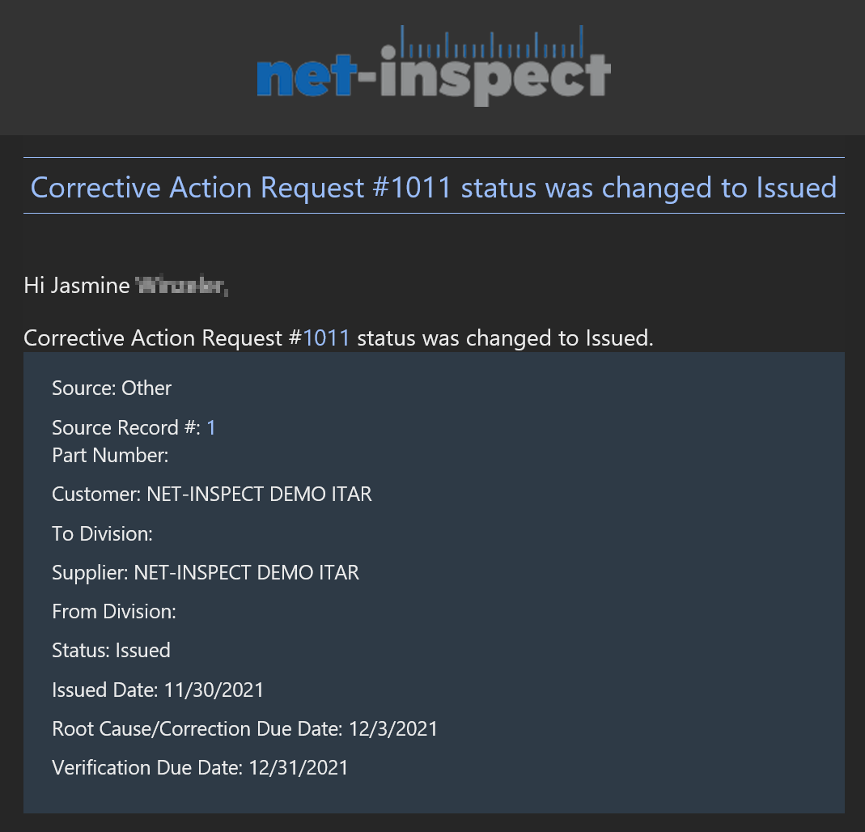
Daily email highlighting open Corrective Actions.
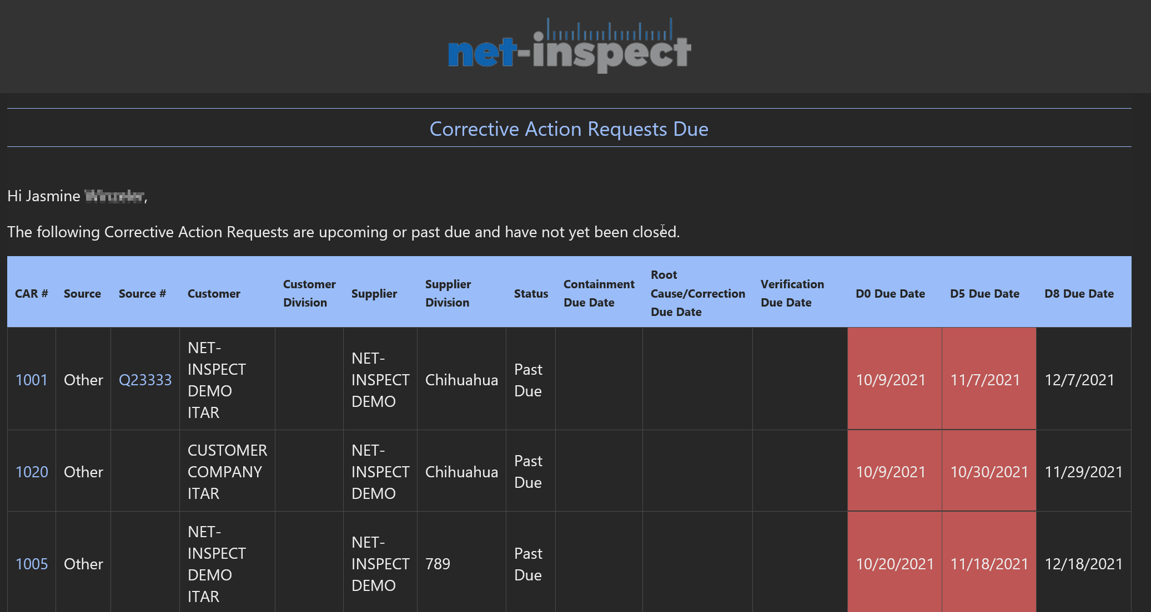

Email notification for CAR status change.

Email Notification Settings

The user can “Opt In” to subscribe to module event notifications. This can be achieved by selecting the user icon on the top right “My Settings” Notifications tab select the last page select “Opt In” for any/ all of the following options:
- Corrective Action Request Status Changed
- Corrective Action Requests Due
- CAR Due Date Extension Requested​
- CAR Due Date Extension Response​
Users can opt out of these at any time but the default setting is “Off”.
